DATA STRUCTURE
LAB PROGRAMS

9. a) Write a C program for implementing array and perform insertion .

#include <stdio.h>
int main()
{
int arr[100], n, i, pos, value;
printf("Enter number of elements: ");
scanf("%d", &n);
printf("Enter array elements:\n");
for(i = 0; i < n; i++)
{
scanf("%d", &arr[i]);
}
printf("Enter position for insertion: ");
scanf("%d", &pos);
printf("Enter value to insert: ");
scanf("%d", &value);
for(i = n; i >= pos; i--)
{
arr[i] = arr[i - 1];
}
arr[pos - 1] = value;
n++;
printf("Array after insertion:\n");
for(i = 0; i < n; i++)
{
printf("%d ", arr[i]);
}
return 0;
}
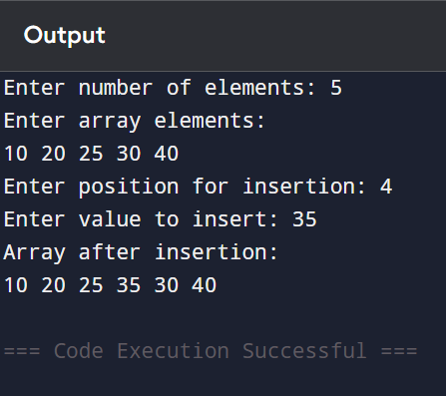

b) Write a C program for implementing array and perform deletion .

#include <stdio.h>
int main()
{
int arr[100], n, i, pos;
printf("Enter number of elements: ");
scanf("%d", &n);
printf("Enter array elements:\n");
for(i = 0; i < n; i++)
{
scanf("%d", &arr[i]);
}
printf("Enter position to delete: ");
scanf("%d", &pos);
for(i = pos - 1; i < n - 1; i++)
{
arr[i] = arr[i + 1];
}
n--;
printf("Array after deletion:\n");
for(i = 0; i < n; i++)
{
printf("%d ", arr[i]);
}
return 0;
}
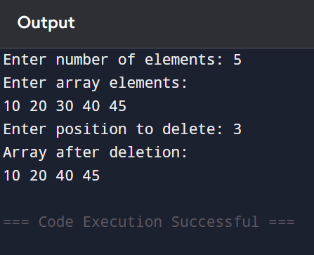
c) Write a C program for implementing array and perform updation .

#include <stdio.h>
int main()
{
int arr[100], n, i, pos, value;
printf("Enter number of elements: ");
scanf("%d", &n);
printf("Enter array elements:\n");
for(i = 0; i < n; i++)
{
scanf("%d", &arr[i]);
}
printf("Enter position to update: ");
scanf("%d", &pos);
printf("Enter new value: ");
scanf("%d", &value);
arr[pos - 1] = value;
printf("Array after updation:\n");
for(i = 0; i < n; i++)
{
printf("%d ", arr[i]);
}
return 0;
}

